

**CASA Super Hero Kid’s K / 5K-10K Fun Run**

**November 12, 2016**

**Liberty Municipal Park**

**501 R.E. Vinson Drive** • **Liberty, Texas 77575**



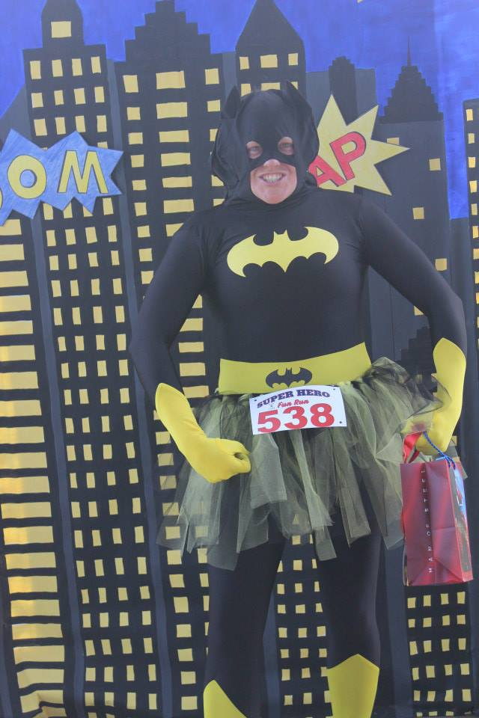 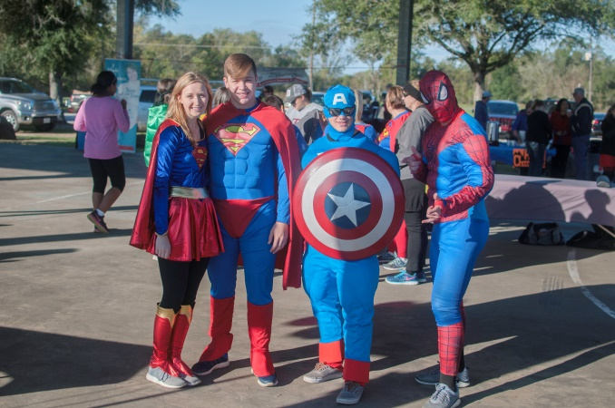

**All Ages Welcome!**

***Every child needs a hero in their life but a CASA child needs a super hero.***

# PROCEEDS BENEFIT CASA LIBERTY/CHAMBERS COUNTIES

The 5K/10K course will use a current high school cross country route along with asphalted park trails winding through the Liberty Municipal Park

The CASA Super Hero Fun Run is a family friendly event designed to raise awareness and funds for the fight against child abuse. Get your super hero costume ready! Wear your cape, mask or t-shirt and come support CASA Liberty/Chambers County. Show abused and neglected children that you care. Become a CASA Volunteer and let your super powers shine!

CASA of Liberty/Chambers Counties advocates for the best interests of children in the foster court system, through the training and support of community volunteers.

If you are interested in helping CASA or becoming a volunteer please contact:

Debbie Dugger, Executive Director 936-334-9000

[ddugger@casalctx.org](mailto:ddugger@casalctx.org)